TNR14, Bold, Right Aligned Chapter 1

TNR14, Bold, Right Aligned Introduction

Currently, neural networks are being used to solve problems related to control. One way to determine the reliability of the neuro-control technique is to test it on a variety of realistic problem. Another way is to compare it directly with existing traditional control techniques, to see whether it works well and where it needs further refinement. In the present work, the neural network based predictive control scheme to control the temperature of the water bath has been developed. Control strategy used is internal model control employing neural networks.
1.5 spacing
Within paragraph

1.1 Relevance
Classical feedback control theory has been the basis for the development of simple automatic control systems. Its easily comprehensible principle and relatively simple implementation have been the main reason for its wide applications in industry. Such fixed gain feedback controllers are insufficient, however, to compensate for parameter variations in the plant as well as to adapt to the changes in the environment. The need to overcome such problems and to have a controller well-tuned not just for one operating point but for a whole range of operating points has motivated the idea of an alternative control schemes.
To be edited in equation editor
Center aligned
Size 12

TNR 12, bold
Double spacing
Within paragraph

(2.1)
TNR 12, bold
Sentence case

G_{m}

+

y_{d}

+

u

y

G_{p}

G_{c}

F

Fig. (2.1) Block diagram of the Internal Model Control (IMC) scheme

Table 2.4 Summary of the MSE performance of the ANN-IMC and PI
TNR 12, bold
Sentence case

Set point ⁰C | PI Controller  Error | ANN-IMC Controller  Error
30 | 3.58 | 1.76
50 | 20.30 | 18.18
45 | 4.9817 | 3.99
65 | 20.85 | 19.79

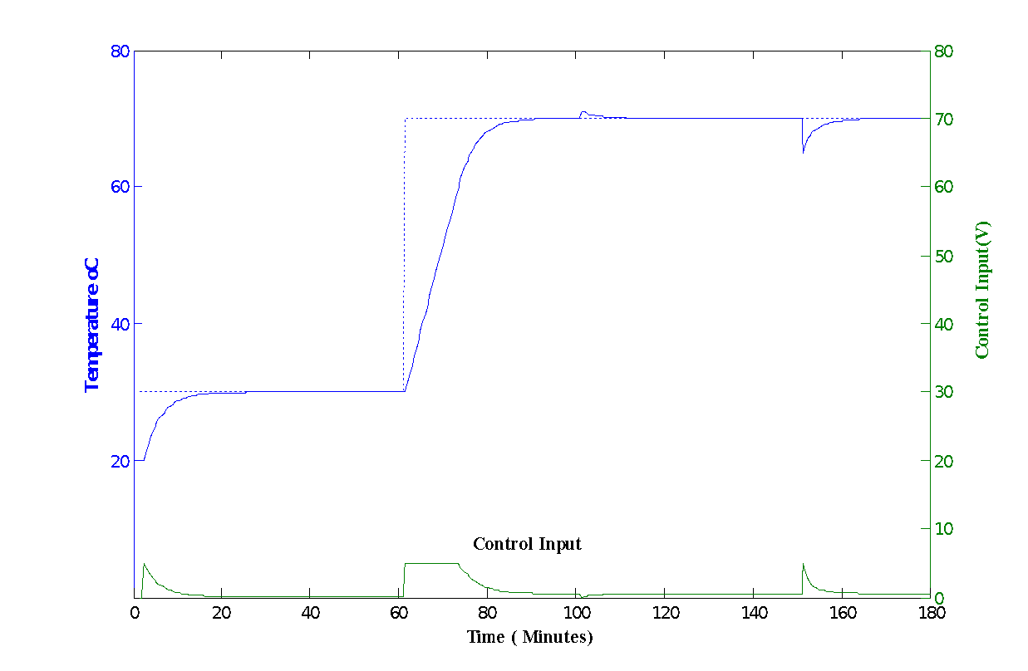
Fig. (2.5) Performance of ANN-IMC controller for set point tracking

TNR 12, bold
Sentence case

